**Experiment 1: Understanding ARM Architecture**

**Objective:** Basic Components of the ARM Architecture:

The ARM (Advanced RISC Machine) architecture is a family of Reduced Instruction Set Computing (RISC) architectures designed for efficient performance. The key components include:

1. **Core Processor:**

* **ALU (Arithmetic Logic Unit):** Executes arithmetic and logical operations.
* **Barrel Shifter**: Used for efficient data shifts and rotations.
* **Multiplier:** For rapid multiplication operations.
* **Pipeline:** Allows instruction-level parallelism (commonly 3, 5, or 8 stages, such as Fetch, Decode, and Execute).

1. **Registers:**

* **General-Purpose Registers (R0-R15):** Used for data storage and computations.
* **Program Counter (PC):** Points to the next instruction to be executed.
* **Link Register (LR):** Stores return addresses for function calls.
* **Stack Pointer (SP):** Points to the top of the stack.
* **Current Program Status Register (CPSR): Holds** flags (e.g., Zero, Carry, Overflow) and mode bits.

1. **Memory Interface:**

* Supports Harvard or Von Neumann memory models.
* Cache memory (L1 and optionally L2).

1. **Instruction Set:**

* ARM instructions (32-bit).
* Thumb instructions (16-bit).
* Conditional execution for efficiency.
* Interrupt Controller:
* Manages hardware and software interrupts.
* (Advanced Microcontroller Bus Architecture).

**Task:** Research and draw the ARM processor architecture, labeling its components.

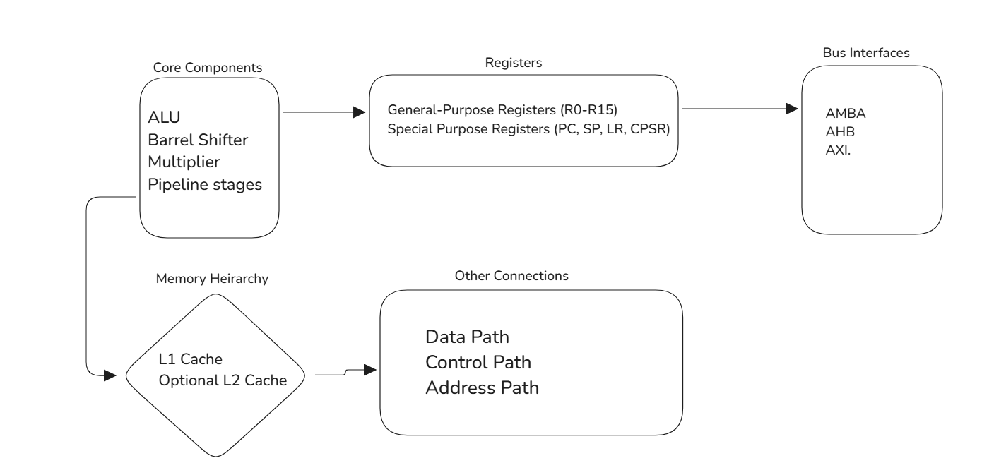

**Experiment: 2**

**Task 1: Load and Store Data using LDR and STR**

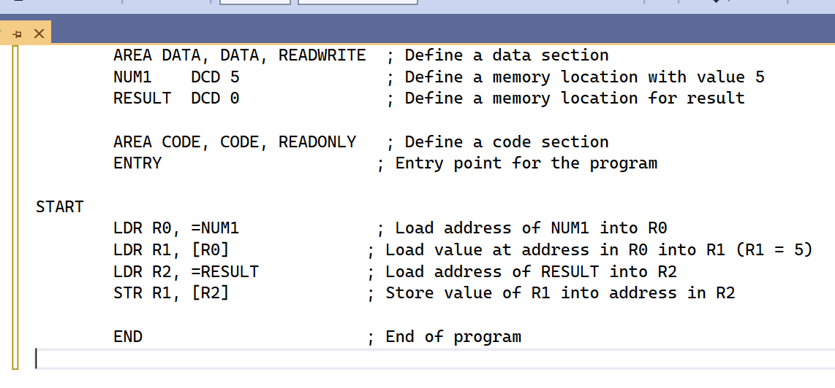

#### ****Task 2: Perform Basic Arithmetic Operations****

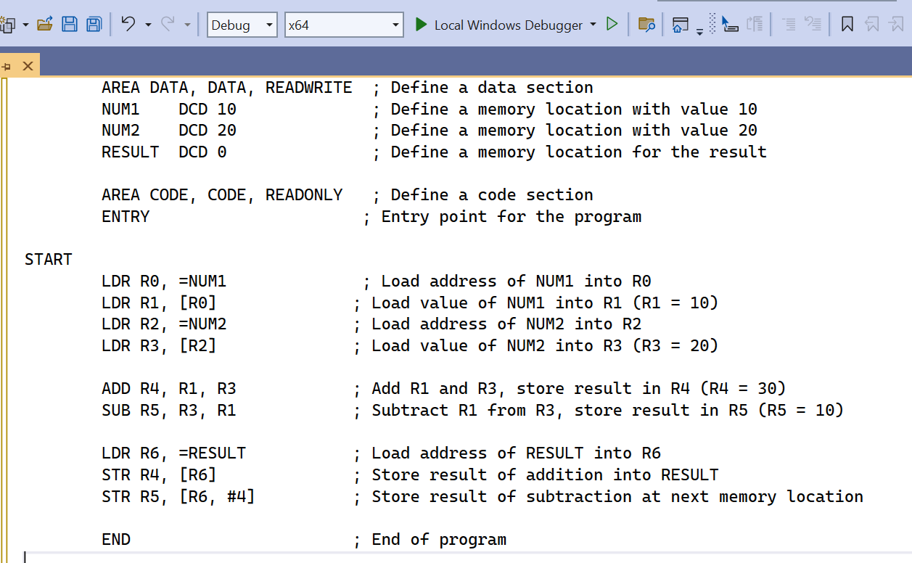

**Experiment: 3**

#### ****Task 1: Compare Two Numbers and Output the Larger Number****

#### 

#### ****Task 2: Implement a Conditional Block Using CMP, BEQ, BNE****

#### 

#### Experiment: 4

#### ****Task 1: Calculate the Sum of the First N Natural Numbers****

#### 

#### ****Task 2: Multiplication Using Iterative Addition****

#### 

#### Experiment: 5

#### ****Task 1: Find the Maximum Value in an Array****

#### 

#### ****Task 2: Bubble Sort an Array****

#### 